04th October 2016

Final race gives Kris Richard the FIA European Touring Car Championship

The intense competition lasted throughout the season and the last two races held at the weekend in Imola were no different. The young Kris Richard had faced the usually dominant Petr Fulin in dramatic competition throughout all the races and the decider had to wait for the last lap in the Italian rounds.

21 year old Honda driver Richard tied on points with Petr Fulín was able to claim the title with a superb final lap to achieve the 2nd place and the difference in having finished three times in second place over Fulin’s two times, to edge the overall triumph in the ETCC Super 2000 category.

In addition to the Championship title, Richard will have guaranteed a one-off drive in next year’s FIA World Touring Car Championship.

In his first season in the ETCC, which boasts the Japanese premium tyre manufacturer YOKOHAMA as Exclusive Tyre supplier, the former single-seater racer from Switzerland took five wins with a particularly special one at the Nürburgring Nordschleife. Honda’s WTCC team boss Alessandro Mariani, William De Braekeleer, Auto Sport Manager of Honda Motor Europe, Zengő Motorsport head Zoltán Zengő and four-time WTCC champion Yvan Muller were in attendance at the ETCC Race of Imola, where Richard took the title in a Rikli Motosport-prepared, TCN2-specification Honda Civic.

Meanwhile Norbert Nagy ended the season in third and one point ahead of Richard’s team-mate Peter Rikli, while Niklas Mackschin rounded out a splendid ETCC Super 1600 title defence by bringing his total of class wins to eight.

In summing up the season, a spokesman for YOKOHAMA Europe expressed satisfaction with the excellent performance of the tyres at all the races and the high level of competition offered by the racing teams.

FIA ETCC Final Standings

Super 2000
1 Kris Richard 109
2 Petr Fulin 109
3 Norbert Nagy 58

Super 1600
1 Niklas Mackshin 138
2 Andreas Rinke 85
3 Kevin Hilgenhovel 81

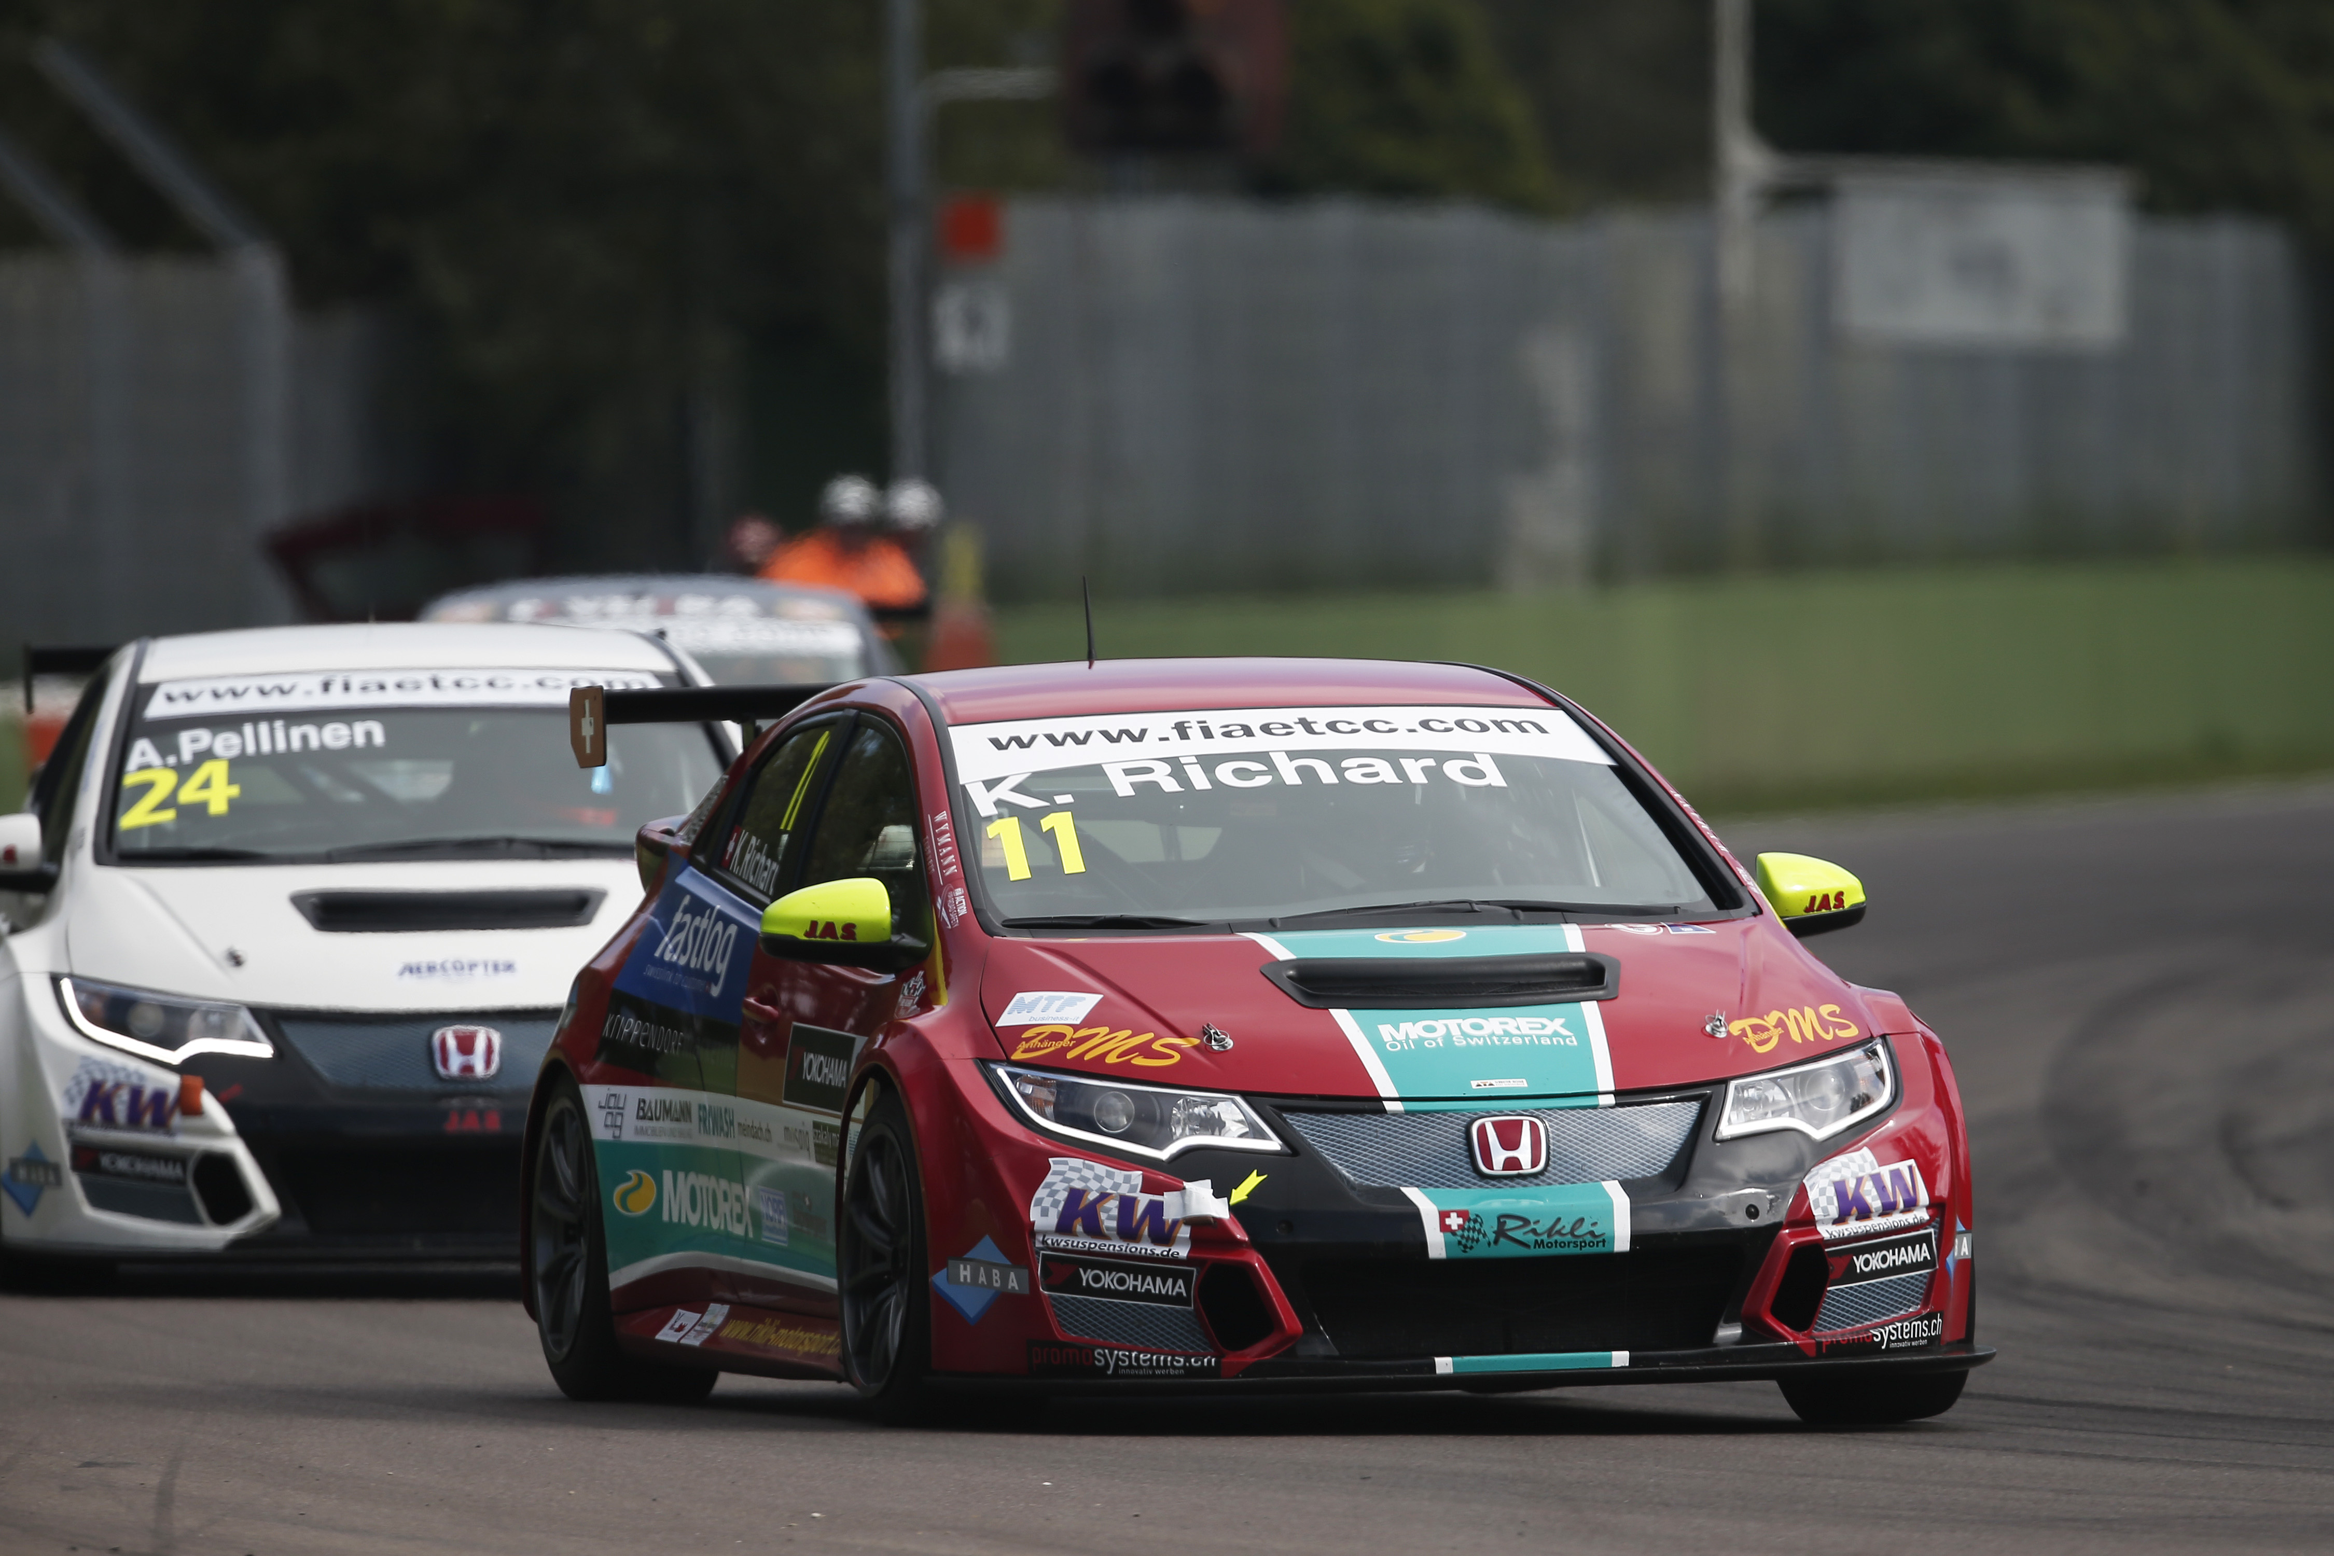
Kris Richard Wins ETCC Super 2000

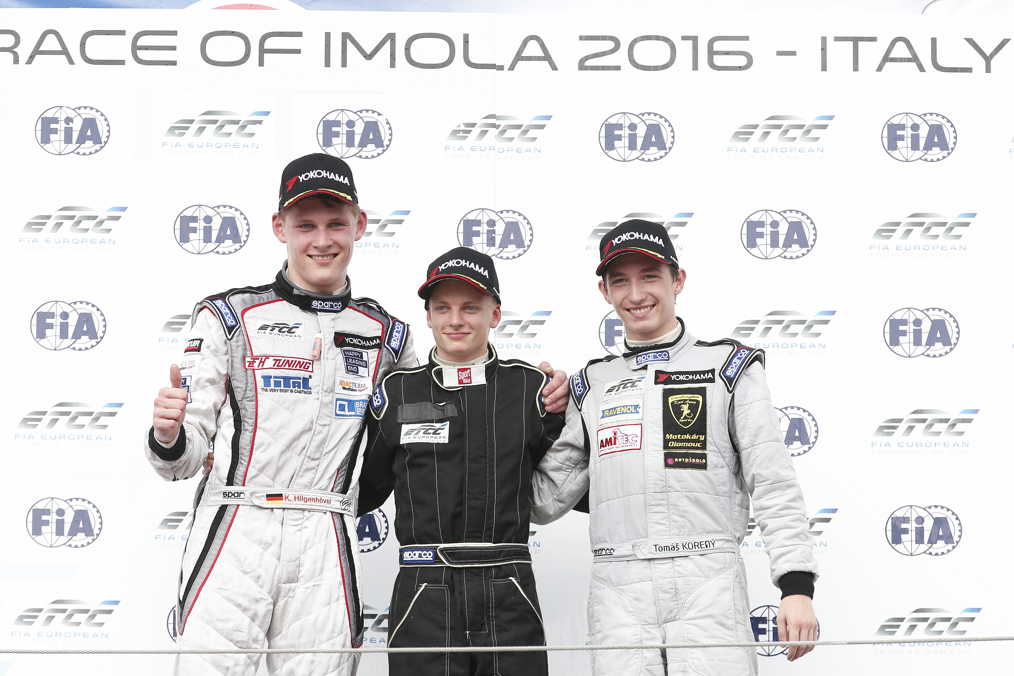
ETCC Drivers with Niklas Mackshin in the centre

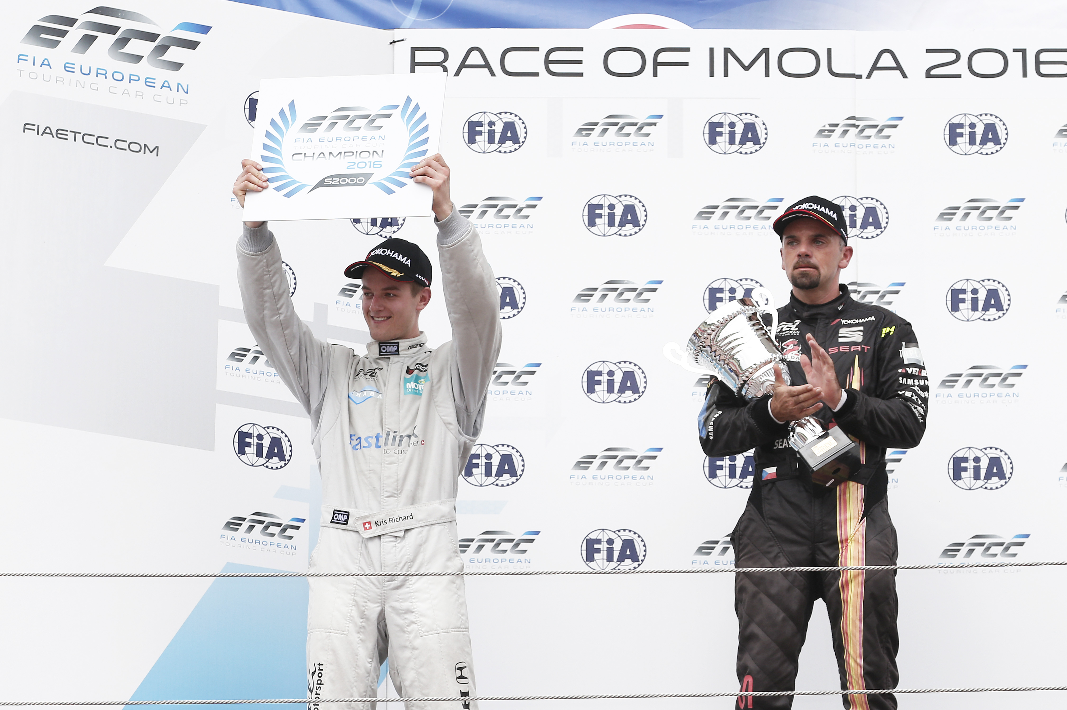
Kris Richard is the 2016 ETCC Champion Super 2000

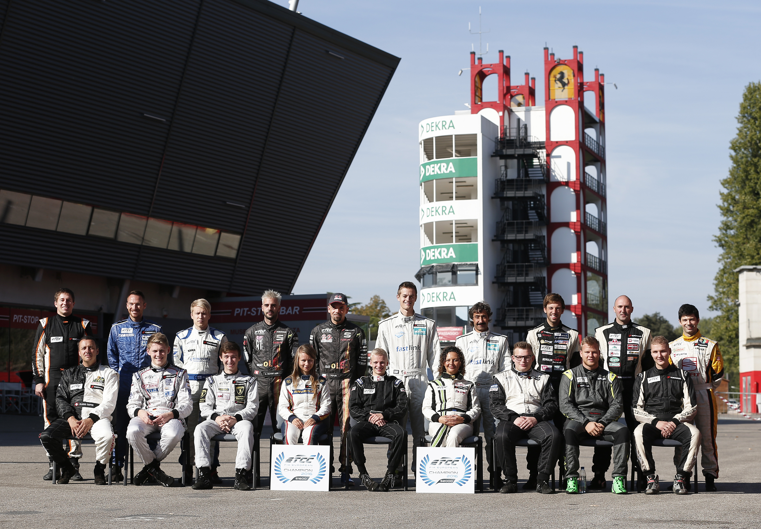
FIA ETCC Drivers Group Shot

